For more information on this property, call (308)962-7445.
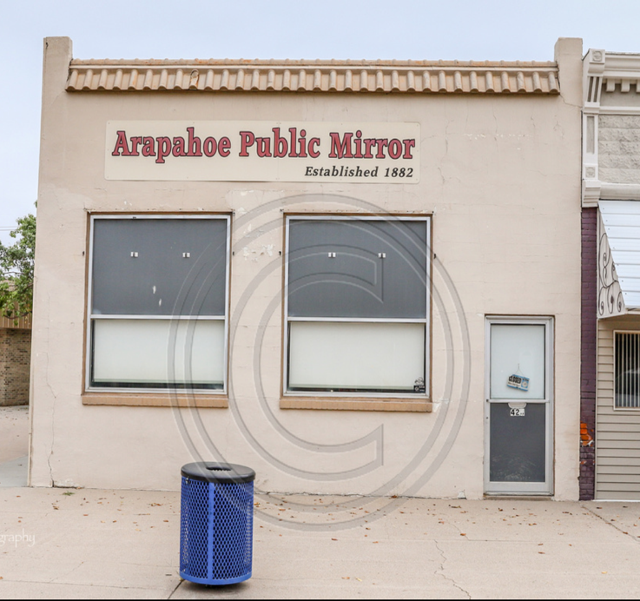
420 Nebraska Ave, Arapahoe, NE
Price: N/A
Status: N/A
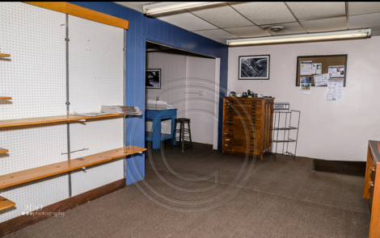
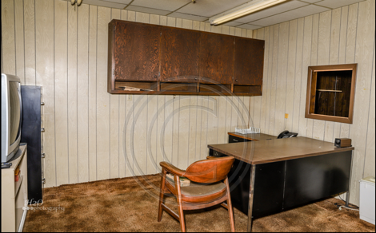

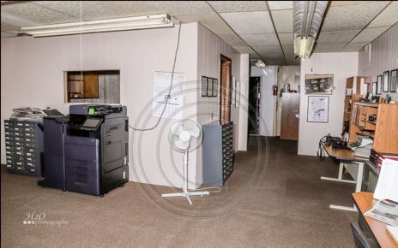
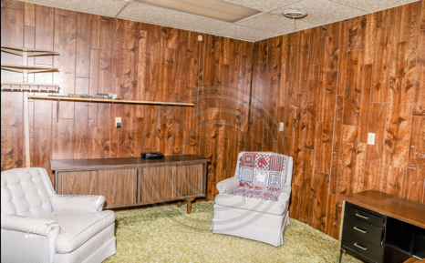

Property Description:
Own a piece of history located directly along Arapahoe's main street of Nebraska Avenue & with lots of traffic. Arapahoe lies at the intersection of two main highways of 6/34 & 283. New windows, paint & façade on the front, rubberized roof recently done. Zoned commercial & perfect for business but could add lofts that would be perfect upstairs! Price at only $150,000 for almost 14,000 s.f. of space! Call Kate Warner today at 970-520-7439.
Primary Features:

County: Furnas
IDX City Name: Arapahoe
IDX County Name: Furnas
Off Market Date: N/A
Photo Count: 23
Property Sub Type: COMMERCIAL
Property Type: Commercial
Sold Date: N/A
Additional:

Approximate Age: 61+ years
Construction:
Miscellaneous:
Present Use: N/A, previous newspaper
Stories: 1
Utilities: City sewer, water
Interior Features:

Approximate SqFt: Main:
Approximate SqFt: Upper: N/A
Building SqFt:
Ceiling Height:
Cooling:
Floors: concrete slab, carpet
Freight Elevator:
Heat Type:
Office SqFt:
Retail SqFt:
Total SqFt:
Warehouse SqFt:
External Features:

Area: Arapahoe
Foundation:
Lot Size:
Number of Units: 1
Overh Door Width:
Overhead Doors:
Overhead Driveway Height:
Parking: Street Parking
Parking Capacity: 5-10
Roof:
Siding: Stucco
Financial Details:

Auction: No
Best Potential:
Flood Insurance:
Possession:
Sale/Rent:
Tax Year:
Taxes:
Terms:
Utilities Average Per Year:
Utility Paid by Owner:
Utility Paid by Renter:

Location Information: Arapahoe, NE
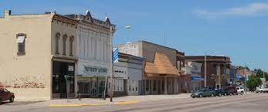
Arapahoe, Nebraska, located in Furnas County, in southwest Nebraska, is a busy, rural community of 1,028. Founded in 1871 and home to the Our Lady of Fatima Shrine, a Veteran's Memorial, numerous parks and ballfields, city pool, municipal golf course, volunteer operated movie theater, and more, we welcome you to Arapahoe and invite you to bring entrepreneurial ventures to buildings like this one!

Education: Arapahoe-Holbrook Public Schools
- Recently renovated in 2018, Arapahoe-Holbrook school provides education and additional opportunities for pre-school to high school students. Our student warriors actively compete in a number of activities including a variety of sports, FFA, FCCLA, quiz bowl, etc.
Healthcare:

- Arapahoe Dental Clinic
- Arapahoe Medical Clinic (Tri-Valley Health System)
- Arapahoe Pharmacy
- Arapahoe Physical Therapy
- Arapahoe Vision Clinic
- Cappel Chiropractic and Personal Training
- Milligan Chiropractic
- Tri-Valley Physical Therapy

Community Life: Recreation:
- First United Methodist Church
- River Valley Evangelical Free Church
- Christian Church of Christ
- St. Paul’s Episcopal Church
- Trinity Lutheran Church
- St. Germanus Catholic Church
- Arapahoe Food Pantry
- Good Samaritan Society
- Arapahoe Public Library
- Crystal Theater
- Arapahoe Ball Parks
- Arapahoe City Park
- Arapahoe Municipal Golf Course
- Arapahoe Municipal South Park
- Arapahoe Plunge and Splash Pad
- Arapahoe Tennis Courts
- Tornado Alley

